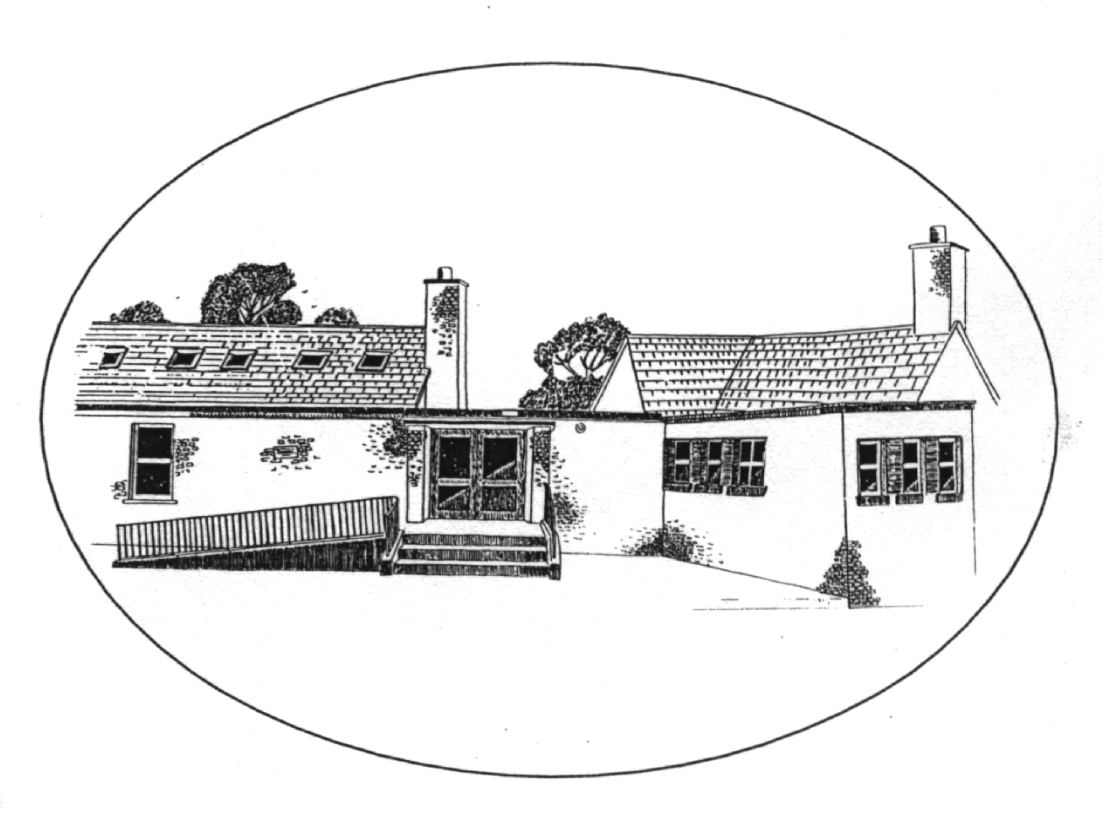
S.N. Mhichíl Naofa, Saint Michael’s N.S
11, Sr.Ó’Bearáin 11, Barrington Saint,
Luimneach. Limerick.
V94 A0K7 V94 A0K7
Uimh. Rolla 12834 S Tel/Fax 061–315927
Email: info@smnslimerick.ie Website: www.smnslimerick.ie
Health & Safety Statement
Introduction
A Health & Safety statement is required by law under the Safety, Health & Welfare at Work Acts (1989 & 2005). This Statement is prepared by the Board of Management (BOM) of Saint Michael’s National School, 11 Barrington Street, Limerick, to set out in writing a programme for safeguarding Safety, Health & Welfare of staff in St Michael’s National School.

It represents the commitments of the BOM to providing a workplace, which is as safe and as healthy as possible for its employees, and specifies the organization, the manner necessary for maintaining and reviewing safety and health standards.

The BOM of SMNS brings to the attention of staff, the following arrangements for safeguarding safety, health and welfare at work. It is reviewed annually, or more frequently if necessary, in the light of experience or changes in legal requirements. The safety statement will be re-examined by the Board on at least an annual basis. The safety statement requires the co-operation of all employees in order to be effective. All records of accidents and ill-health are monitored in order to ensure that any corrective measures required can be put in place to reduce the recurrence of such accidents and ill-health. The Principal will give the Board a summary of incidents as they arise.

The Board of Management of Saint Michael’s National School wishes to ensure as far as is reasonably practicable that:
- The design, provision and maintenance of all places in the school are safe and without risk to health.
- There are safe access to, and egress from, places of work.
- Equipment may be operated safely.
- Work systems are planned, organized, performed and maintained so as to be safe and without risk to health.
- Staff are instructed and trained as necessary to ensure health and safety.
- Protective clothing or other appropriate clothing are provided as necessary to ensure safety and health.
- Plans for emergencies are complied with and revised as necessary.
- Employees are consulted on matters of health and safety.

The BOM recognises that its statutory obligations under legislation extend to employees, pupils, student-teachers, to any person legitimately conducting school business off-site or legitimately conducting other business on the school premises. The Board of Management of SMNS undertakes to ensure that the provisions of the Safety, Health and Welfare at Work Act 2005 are adhered to.

Duties of Employees
It is the duty of every employee while at work:
(a) To take reasonable care for his/her own safety, health and welfare, and that of any person, who may be affected by his/ her acts or omissions while at work. Each employee has a duty to look after him/herself.
(b) To co-operate with his/ her employer and any other person to such extent as will enable his/her employer or the other person to comply with any of the relevant statutory provisions.
(c) To use, in such manner so as to provide the protection intended, any suitable appliance, protective clothing, convenience, equipment or thing provided for securing his/her safety, health or welfare at work.
(d) To report to the BOM without unreasonable delay, any defects in plant, equipment, place or work, or system of work, which might endanger safety, health or welfare.
(e) The Chairperson of the BOM has a responsibility to ensure that all employees are not putting themselves in harm’s way of the duties being undertaken.

No person will intentionally or recklessly interfere with or misuse any appliance, protective
clothing, convenience or other means or thing for securing safety, health or welfare at work. Employees using available facilities and equipment provided, must ensure that work practices are performed in the safest manner possible.

Role of the Safety Representative
The BOM will consider reasonable representations made by the safety representative on behalf of the staff. Maria Robinson is the current Safety Representative and each term she reminds staff to report issues to her directly.

Consultation and Information
It is the policy of the BOM, or the BOM representative, to consult with staff in an annual review of risk assessments at the beginning of each school year. A copy of the safety statement is made available to all staff via e mail at the beginning of the school year.

Health, Safety and Welfare work will be considered in any future staff training and development.

The Health & Safety Statement is displayed in a public place in the school. All staff members will be asked to read the Health & Safety Statement at the start of each school year and this will be recorded and dated. All work experience students and long term substitutes will be asked to read the Health and Safety Statement before commencing their role in our school. This will also be recorded.

Hazards
Hazards shall be divided into two categories. Those which can be rectified, will be dealt with as a matter of urgency. Those that cannot, will be clearly indicated and appropriate procedures listed beside them. All hazards shall be eliminated in so far as resources and circumstances allow.

Fire
(i) The Board ensures that an adequate supply of fire extinguishers, suitable for the type of fires likely to occur in each area, is available, identified and regularly serviced by authorised and qualified persons. Each fire extinguisher has instructions for its use.
(ii) The Principal ensures that fire drills take place at least once per term.
(iii) Signs are clearly visible to ensure that visitors are aware of exit doors and routes.
(iv) All doors, corridors, and exits are kept clear of obstruction and are able to be opened at all times from within the building. Each teacher, who has an exit in the classroom, must ensure it is kept clear. Back and main doors must be free of obstruction.
(v) The assembly point is in the yard.
(vi) All electrical devices should be left unplugged, when unattended for lengthy periods and when the building is empty, where practical. Teachers are responsible for their own classrooms. The Principal and the school secretary are responsible for the office. The general kitchen area is each staff members’ responsibility.
(vii) Any recommendations made by a Fire Officer in addition to these provisions will be implemented.

Risk Assessment
The following hazards (in so much as can be identified) are considered by the BOM to be a source of potential danger and are brought to the attention of all concerned.
1. Wet corridors
2. Trailing leads
3. Computers
4. Guillotine
5. Projectors
6. Fuse Board
7. Electrical appliances
8. Boiler house
9. Ladders
10. Surface of school yard
11. Protruding units and fittings
12. External stores (to be kept locked)
13. Icy surfaces on a cold day
14. Ramp entering the school when wet/icy or when wet leaves have gathered

To minimise risks from these sources, the following safety/ protective measures must be adhered to (see duties of employee pages 1-2 of this document):
(a) All equipment is to be used in strict accordance with the manufacturer's instructions and recommendations.
(b) Where applicable the Board will ensure that members of staff are instructed in the correct use of plant, machinery and equipment.
(c) Operation of equipment is restricted to those members of the staff whose job function includes running, maintaining, cleaning and monitoring particular items of plant in the course of their normal duties.
(d) Before engaging a contractor, the Principal/ or BoM will send a copy of this Safety Statement to them. Any other contractors entering the school must be shown a copy of the school's Health & Safety Statement and must adhere to its provisions.
(e) All items of electrical equipment are fitted with adequate safeguards.
(f) Precautionary notices, in respect of safety matters are displayed at relevant points.
(g) Ladders must be used with another person's assistance.
(h) Staff will avoid use of glass bottles by pupils, where possible. Remove broken glass immediately on discovery.
(i) The Board will check that floors are clean, even, non-slip and splinter-proof.
(j) The staff will ensure that PE equipment is stacked securely and positioned so as not to cause a hazard.
(k) All personnel check that all PE and other mats are in good condition and not presenting trip hazards.
(i) There is an on-going inspection of furniture, floors, apparatus, equipment and fittings by staff. Any faults are reported on Aladdin, which is accessed daily.
(m) The staff check that wooden beams, benches, etc. are free from splinters and generally sound.
(n) A caretaker or other person designated by the BOM, checks that there are no uneven, broken or cracked paving slabs.
(o) The BOM's representative with the caretaker, checks that roofs, guttering, drain pipes, etc. are sound and well-maintained as far as can be seen.
(p) Staff check that manholes are safe.
(q) Staff check that all play areas, are kept clean and free from glass before use.
(r) The BOM checks that outside lighting works and is sufficient.
(s) The caretaker ensures that all building materials, caretakers' maintenance equipment, external stores, etc. are stored securely.
(t) The staff checks that refuse is removed from the building and is carefully stored outside in a location likely to minimise damage in the event that it should catch fire.

Constant Hazards
Machinery, Kitchen Equipment, Electrical Appliances
It is the policy of the BOM that machinery, kitchen equipment and electrical appliances are to be used only by competent and authorised persons. Such appliances and equipment are visually checked at each use.

Electrical Appliances
Arrangements will be made for any appliances in need of servicing, to be checked on a regular basis. Before using any appliance, the user should check that:
- All safety guards which are a normal part of the appliance are in working order
- Power supply cables/leads are intact and free of cuts or abrasions.
- Suitable undamaged fused plug tops are used.
Unplug leads of appliances when not in use.

Chemicals
It is the policy of the Board that all chemicals, photocopier toner, detergents, etc be stored in clearly identifiable containers bearing instructions and precautions for their use. These are kept in a closed cupboard and, where needed, protection is provided to be used when handling them.

Highly Polished Floors
Every attempt will be made to avoid the creation of slippery surfaces. Floors are washed, as far as is possible, after school hours to minimise the danger of slipping. Where floors are wet, warning signs regarding wet floors, should be used where practicable. Attention is drawn to the possibility of outside surfaces being affected by rain in wet weather , wet leaves and frost in cold weather. Where possible staff and pupils shall be reminded to use handrails when going up or down ramps.

Smoking
The entire school premises, both indoors and outdoors, is deemed a non-smoking premises to avoid any hazard of passive smoking.

Broken Glass
Staff are asked to carefully remove broken glass. Children are instructed to report broken glass to a teacher and are warned never to pick up broken glass or foreign items they may find on the yard.

Visual Display Units
The advice contained in the Health & Safety Authority’s (HAS) guidelines on the safe operation of visual display units is followed. Any up-to-date information regarding hazards relating to the use of VDUs will be studied and recommendations and directives implemented.

Infectious Diseases
It is the policy of the BOM that all infectious diseases shall be notified and steps taken to ensure the safety of staff and students against all such diseases. The BOM will endeavour to minimize the risk by adherence to sound principles of cleanliness, hygiene and disinfection, and have provided disposable gloves for use in all First Aid applications, cleaning tasks, etc. Toilets and washrooms are provided at all times with a facility for the safe disposal of waste.

First Aid
All staff are currently first aid trained. This will be due for renewal in November 2019.
The first aid box is located at the side-entrance (wall-mounted), in the office and in each classroom. Contacts for the school doctor and emergency services are to be found on page 6 of this document.
- A notice is posted on the main notice-board, in the office and in the staff-room, detailing contact numbers of relevant personnel.
(2) All incidents, no matter how trivial and whether to employees or to students or to members of the public, must be reported immediately to the member of staff on duty and/or the Principal. This is necessary to monitor the progress of safety standards and to ensure that the proper medical attention is given where required. The staff member on duty keeps an Accident Report File, recording all accidents and incidents.

The Principal will see that there will be maintained in the school, a properly equipped First Aid Box available to staff at all times containing:
- Sticking plasters
- Anti-histamine for Stings, etc.
- Tape
- Disinfectant (e.g.) Savlon
- Eye lotion (e.g.) Optrex
- Antiseptic cream
- Cotton Bandage
- Cream for First Aid treatment of Burns
- Antiseptic Wipes
- Scissors
- First Aid Chart
Disposable gloves must be used at all times in administering First Aid.
(The school will also carry out Guidelines as provided under the Critical Incident policy.)

To ensure the continued welfare of the staff and children, toilet and cloakroom areas are provided. A high standard of hygiene must be achieved at all times. Adequate facilities for waste disposal must be available. An adequate supply of hot and cold water, towels and soap and sanitary disposal facilities are available.

Staff Facilities
Tea and lunch breaks are taken in either the classroom (when the teacher is on out/inside supervision duty) or in the Staff Room, adjacent to the kitchen. Pupils and duty staff eat during the first ten minutes of break-time. Staff must co-operate in maintaining a high standard of vigilance in this area.

Members of staff are reminded that:
(a) A person, who is under medical supervision or on prescribed medication and who has been certified fit for work, should notify the school of any known side effect or temporary physical disabilities, which could hinder their work performance and which may be a danger to either themselves or their fellow workers. The school will arrange or assign appropriate tasks for the person to carry out in the interim.
(b) Staff members are not allowed to attend the premises or carry out duties whilst under the influence of illicit drugs or alcohol.

Contractors & Access To School
Anyone entering the school premises must:
- identify themselves to a member of staff before gaining admittance to the school and
- provide a copy of their current schedule of insurance.
Any contractor must make direct contact with the Principal, before initiating any work on the premises and be shown a copy of the Health & Safety statement applying to the school and must agree to its provisions. While work is in progress, noise shall be avoided wherever possible during school hours. The contractor and his workmen shall not create any hazard, permanent or temporary, without informing the Principal and shall mark such hazard with suitable protection or at least with warning signs.

Contact Phone Numbers

Emergency Services 999/112
Mid-West Regional Hospital 061-301111
School Doctor – Dr. Philip Cullen 061-314810
Roxboro Garda Station 061-419555
Henry Saint Garda Station 061-212400
ESB 061-414592

Review of this Safety Statement
This statement shall be regularly revised by the Board of Management of St Michael’s NS in accordance with experience and the requirements of the Safety, Health and Welfare at Work Act 2005 and the Health and Safety Authority.

The Safety Statement is also made available to all staff, who have been forwarded a copy and requested to read the Health & Safety Statement.

Signed on behalf of the Board of Management

Chairperson of BOM: _____________________________________

Date: _________________________

(The Health & Safety Statement was prepared by representatives of the school community, in accordance with the Safety, Health and Welfare Act at Work Act 2005.)

Health & Safety Representatives Derek Lew (BOM)
Maria Robinson (Staff)

Please note: This plan is subject to change based on emerging needs .

Appendix 1
I can confirm that I have read the Health and Safety statement of Saint Michael’s National School and I understand my role.
Name in Block Capitals | Signature | Date

Name in Block Capitals | Signature | Date

Appendix 2
Saint Michael’s NS Safe System of Work for off-site school excursions
Lead Person: |  |  | Reason for visit (Tick)
Accompanied by: |  |  | Swimming
Bus Operator |  |  | School tour
Location: |  |  | Other
Date: |  | Safety Ref. No.:
I have read & understood the School H&S Safety Statement . Tick
Before Leaving School the Following Must be in Place & in Date:
Appropriate Garda Vetting |  |  | Charged Mobile Phone | Location Known by School |  |  | Personal Protective Equipment |  |  | List of Children | Check Forecast
PPE |  | Please tick/fill in the PPE used
Hi Vis jacket/Vest |  | Torch
CHECK HAZARD CHART BEFORE PROCEEDING
If it’s not safe don’t do it!
Comment & hazards identified:
On the back of this form is a list of potential hazards that may be encountered while off school grounds. You are asked to tick if the hazard is present and give it a risk rating of high, medium or low.
Hazards present (hazard Numbers identified)
Comment & additional hazards identified:

If an incident has occurred have you filled out the incident report form? (If Yes tick box)
Signed:___________________________ Date:_____________________________
Reviewed
Date: | Date: | Date:
Person | Person | Person
Comment | Comment | Comment

Haz  No. | Hazard | Standard Controls |  |  |  |  |  |  |  |  |  |  |  |  |  |  |  |  |  | Tick if Present | Risk H/M/L
 | Getting on and off bus | (a)Bus must Park in Visible, clean Area |  |  | (b) Must alight/ disembark onto footpath or other controlled area |  |  |  |  | (c )Keep back from corners/ blind spots
 | Walking on the Public Road | - (a) Teachers to Wear High Visibility clothing |  |  |  |  | - (b) Walk on the right hand side |  |  |  |  |  | - (c) Beware of oncoming traffic |  |  |  | (d)Use footpaths if available
 | Crossing the Public Road | (a) Teachers to Wear High Visibility clothing |  | (b) Cross at pedestrian crossings where available |  |  |  |  | (c) Children to walk in pairs |  |  |  |  | (d) Beware of oncoming traffic
 | Slippery/Wet /Uneven Surfaces |  | (a) Wear Suitable Footwear |  |  |  |  |  | (b) Keep Hands Free |  |  |  |  | (C )Avoid Worst Areas
 | Dogs | (a) Avoid Close Contact by children
 | Running in the Park | (a) Ensure that children are in sight at all times |  |  |  | (b) Make sure children know where teachers are to stand. |  |  |  |  |  |  | (c) Ensure that children are in pairs |  |  |  | (d) Don’t stand behind when reversing
 | Aggressive members of the public | - (a) Don’t get into an argument leave |  |  |  |  |  | - (b) Request Garda Presence if required |  |  |  | - (c) Contact school secretary before and after visit.

