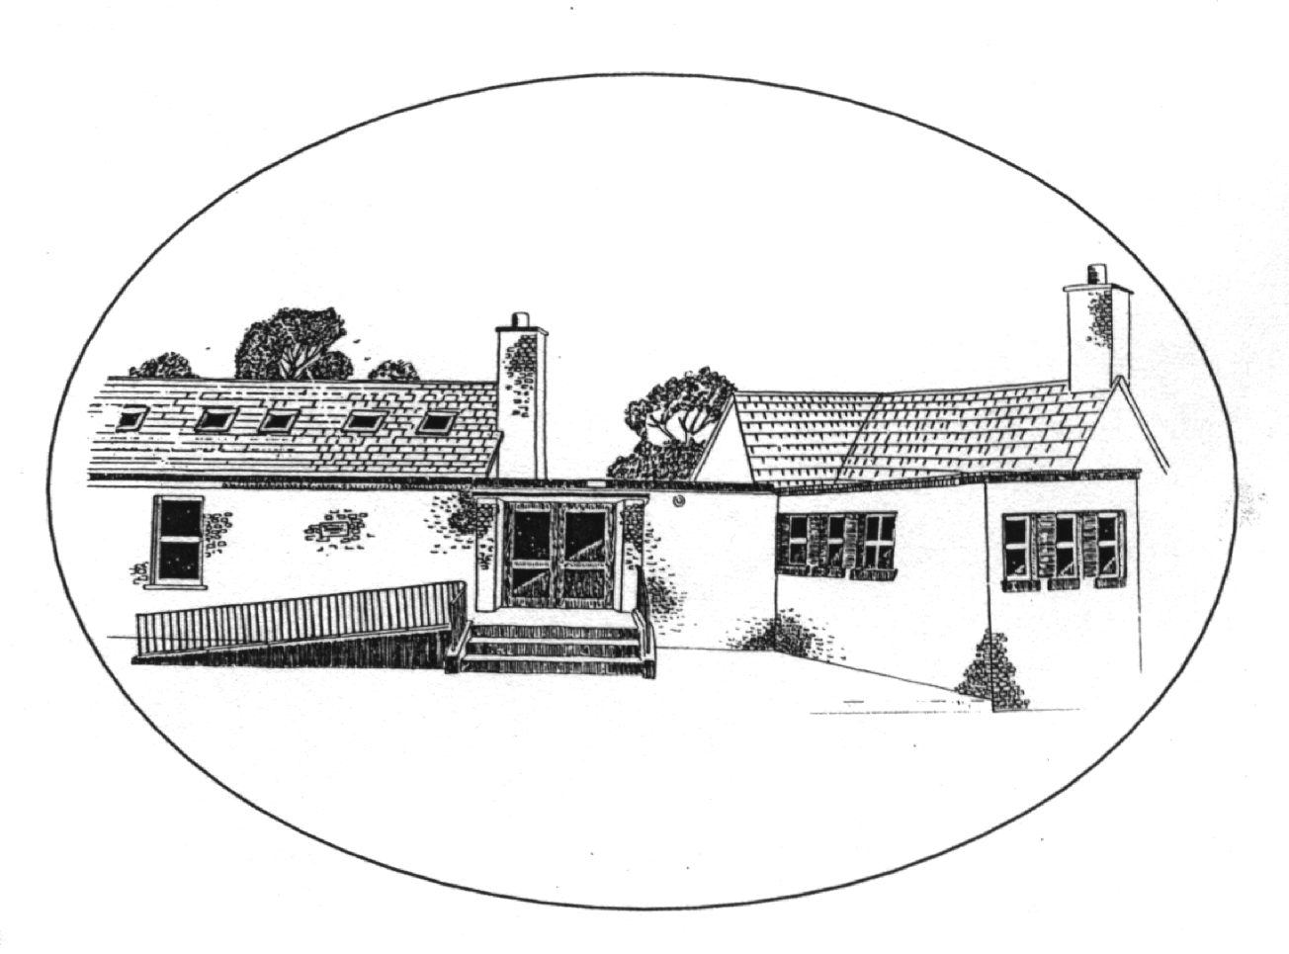
S.N. Mhichíl Naofa, Saint Michael’s N.S
11, Sr.Ó’Bearáin 11, Barrington Saint,
Luimneach. Limerick.
V94 A0K7 V94 A0K7
Uimh. Rolla 12834 S Tel/Fax 061–315927

Email: info@smnslimerick.ie Website: www.smnslimerick.ie

Attendance Strategy Statement
Introductory Statement
This statement was drawn up using the draft guidelines from the PPDS Website. It was drawn up by Ms. Maria Robinson, in consultation with the staff and the Board of Management of Saint Michael’s N.S. The policy was revised in September 2017 and will be ratified at a Board of Management meeting in November 2017.

Rationale
Saint Michael’s N.S. decided to devise this strategy –
- as it is a requirement under the Education Welfare Act 2000
- to encourage good school attendance
- to inform the school community as a whole of procedures and requirements in relation to attendance
- existing statement is due for review and amendment.

Relationship to characteristic spirit of the school
We in Saint Michael’s N.S. recognise the importance of good school attendance. In accordance with the ethos of our school we will endeavour to ensure that all staff, pupils and associates of the school will be encouraged to make regular attendance at school.

The aims of the attendance policy in Saint Michael’s N.S. are to:
- Encourage pupils to attend school regularly and punctually.
- Share the promotion of school attendance amongst all in the school community.
- Inform the school community of its role and responsibility as outlined in the Education Welfare Act 2000.
- Identify pupils who may be at risk of developing school attendance problems.
- Ensure that the school has procedures in place to promote attendance/participation.
- Develop, subject to available resources, links between the school and the families of children who may be at risk of developing attendance problems.
- Identify and remove, insofar as is practicable, obstacles to school attendance.

The school will ensure that:
- The importance of school attendance is promoted throughout the school.
- Pupils are registered accurately and efficiently.
- Pupil attendance is recorded daily.
- Parents or guardians are informed when reasons for absences are unknown or have not been communicated.
- Pupil attendance and lateness is monitored.
- School attendance statistics are reported as appropriate to:
- Tusla

- The Education Welfare Officer
- The Board of Management
- The parents - via newsletter.
Punctuality
School commences at 8.40am. All pupils and teachers are expected to be on time. The school will contact parents/guardians in the event of pupils being consistently late. The Principal is obliged under the Education Welfare Act, to report children who are persistently late, to Tusla.

Guidance for Parents
Section [(21) (9)] of the Act states that: “a pupil’s absence can only be authorised by the Principal when the child is involved in activities organised by the school or in which the school is involved”. The school principal cannot authorise a child’s absence for holidays during school time. However, it is essential that parents inform the school of such arrangements.

Reasons for pupils’ absences must be communicated in writing, by parents/guardians to the school and these will be retained by the school. Parents are required to complete the school’s absence form and place it in the school post box. Please see Appendix A

Parents/guardians can promote good school attendance by:
- Ensuring regular and punctual school attendance.
- Notifying the school if their children cannot attend for any reason.
- Working with the school and Education Welfare Service to resolve any attendance problems.
- Making sure their children understand that parents support and approve of school attendance.
- Discussing planned absences with the school.
- Refraining, if at all possible, from taking holidays during school time.
- Showing an interest in their children’s school day and their children’s homework.
- Encouraging them to participate in school activities.
- Praising and encouraging their children’s achievements.
- Instilling in their children, a positive self-concept and a positive sense of self-worth.
- Informing the school in writing of the reasons for absence from school.
- Ensuring, insofar as is possible, that children’s appointments (with dentists etc), are arranged for times outside of school hours.
- Contacting the school immediately, if they have concerns about absence or other related school matters.
- Notifying the school if their child/children, particularly children in junior classes, are to be collected by someone not known to the teacher.

Pupils
Pupils have the clear responsibility to attend school regularly and punctually.
Pupils should inform staff if there is a problem that may lead to their absence.
Pupils are responsible for placing absence notes from parents into the school post box.
Pupils are responsible for passing school correspondence to their parents, on the specified day.

A strategy for promoting good school attendance

The Board of Management of Saint Michael’s N.S. is committed to providing a positive school atmosphere which is conducive to promoting good school attendance.
In this regard:

- The school curriculum, insofar as is practicable, is flexible and relevant to the needs of the individual child.
- The school will promote development of good self-concept and self-worth in the children.
- Support for pupils, who have special educational needs, are in place in accordance with Department of Education & Science guidelines.
- Internal communication procedures are in place to inform teachers of the special needs of pupils.
- The assistance of the Education Welfare Officer will be utilised if required.
- Through the effective use of Aladdin the attendance rates of pupils will be monitored by the class teacher in the first instance, and the class teacher will notify the Principal of any concerns regarding the attendance of any child.
- Pupils with a poor attendance record will, insofar as is practicable, be supported in an effort to improve their attendance.
- Regularly publish school attendance statistics in school newsletter.
- Attendance is stressed and discussed at Parent Teacher meetings.
- Attendance record on end of year reports.
- Award for full attendance at end of year school ceremony.

School Principal
The School Principal will:
- Ensure that the school register of pupils is maintained in accordance with regulations.
- Inform TUSLA:
- If a pupil is not attending school regularly.
- When a pupil has been absent for 20 or more days during the course of a school year.
- If a pupil has been suspended for a period of six or more days.
- When a pupil’s name is removed from the school register. A pupil’s name may only be removed from the school register where :

- a student has been expelled and all internal and external appeals processes have been exhausted
or
- the school has received confirmation that the student is registered in another school
or
- a student has been registered with the NEWB as in receipt of an education in a place other than a recognised school.
- Inform parents of a decision to contact the Education Welfare Officer of concerns regarding a pupil.
- Insofar as is practicable, promote the importance of good school attendance among pupils, parents and staff

Class Teacher
The class teacher will:
- Maintain the school roll-book in accordance with procedure.
- Contact parents in instances where absences are not explained in writing.
- Encourage pupils to attend regularly and punctually.
- Inform the Principal of concerns she may have regarding the attendance of any pupil.

Records/Communication
Subject to the restrictions of the Data Protection Act attendance, behaviour and academic records of children who transfer to another primary school will be passed to the Principal of the school, by post, as soon as we receive written notification of transfer.
Attendance, behaviour and academic records of children who transfer from another primary school will be sought directly from the previous school.
Attendance, behaviour and academic records of pupils transferring to a second level school will be sent to the school, if requested, once enrolment has been confirmed.

Note
Explained and unexplained absences are recorded on Aladdin
Attendance reports are submitted online as required by Tusla.
An end of year report is submitted online at the end of each academic year.

Absences
Teachers
Where a teacher is absent without substitute cover the following arrangement is in place. Substitute teachers are employed according to the regulations of the DES. Every effort is made to employ qualified teachers in substitute positions.
In the event of an EPV (course day) absence, the class teacher leaves work for the children to do during the day.
The prior approval of the Chairperson of the Board of Management must be granted for scheduled/planned absences.

Children
In line with the Education Welfare Act 2000, every absence by a child must be explained in writing by the parent/guardian.
Written explanations are provided to the class teacher and are retained in the school.
Children are not permitted to leave the school premises during school hours except with the consent of a parent/guardian and must be collected from classroom.
Section 21 of the Education Welfare Act 2000 places an obligation on the school to notify the Education Welfare Officer of absences exceeding 20 school days or more.
In Saint Michael’s N.S., this is the responsibility of Ms Robinson.

Success Criteria
A good attendance record will indicate our measure of success.

Roles and Responsibility
Board of Management, Principal, Ms. Robinson as designated teacher with responsibility in this area, class teachers and parents all have a role and responsibility as outlined in the sections above.

Implementation Date
This policy will be implemented immediately.

Review
It will be reviewed in November 2019 or sooner if required by legislation or if deemed necessary.

Ratification and Communication
The Board of Management officially ratified the policy on the 7th November, 2017
A copy of Attendance Strategy Statement will be made available to all staff. A copy of the statement will be kept on file in the principal’s office with other administration policies. Parents are informed of the availability of the policy for inspection in the school.

Signed: Jennifer O’Leary

Chairperson: Jennifer O’Leary

